

SEND Information Report

Frome College SEND Team
SENCO - Bill Owsley, Assistant Principal
Deputy SENCO - Becca Blake
Strategic SEN Support - Amy Nicholls & Gavyn Upham
Enhanced Learning Provision Teacher – Emma Hurst
SEN Administrator – Kerry Jones
Link Governor - Marianne Johnson
For all general enquiries and questions, please email: senco@fromecollege.mnsp.org.uk

Higher Level Teaching Assistants:
Amy Nicholls
Gavyn Upham

Teaching Assistants
Kevin Exley
Corrine Foot
Madeleine Hewitt
Mark Hewitt
Laura Klucinska
Carole Leigh
Heidy Parfitt
Katie Rux
Harley Shergold
Kaz Smith
Jaidon Sutcliffe
Catherine Trijard
Harper Zriel

Contents

Frome College SEND Team
1.1 The kinds of SEND that are provided for
1.2 Identifying students with SEND and assessing their needs
1.3 Consulting and involving students and parents
1.4 Assessing and reviewing students' progress towards outcomes
1.5 Supporting students moving between phases and preparing for adulthood
1.6 Our approach to teaching students with SEND
1.7 Adaptations to the curriculum and learning environment
1.8 Additional support for learning
ELP – Enhanced Learning Provision
1.9 Expertise and training of staff
1.10 Securing equipment and facilities
1.11 Evaluating the effectiveness of SEND provision
1.12 Enabling students with SEND to engage in activities available to those in the college who do not have SEND
1.13 Support for improving emotional and social development
1.14 Working with other agencies
1.15 Complaints about SEND provision
1.16 The local authority local offer
Introduction
How is the Local Offer is produced?
Working with parents and young people
Get in touch

The kinds of SEND that are provided for
Frome College currently provides additional and/or different provision for a range of needs, including:
    - Communication and interaction, for example, Autistic Spectrum Disorder, speech and language difficulties
    - Cognition and learning, for example, dyslexia, dyspraxia
    - Social, emotional and mental health difficulties, for example, attention deficit hyperactivity disorder (ADHD)
    - Sensory and/or physical needs, for example, visual impairments, hearing impairments, processing difficulties, epilepsy
    - Moderate and multiple learning difficulties.

Identifying students with SEND and assessing their needs
Frome College identifies and assesses the needs of students in various ways:
    - Through on-going teacher observations, assessments, experience
    - Via baseline testing screeners e.g. CATs, EXACT, reading ages
    - Through dyslexia screening tests
    - Through a teacher/parent expressing a concern, and then implementing a cycle of ‘Assess, Plan, Do and Review’
    - Using outside agency reports, including paediatrician diagnosis
    - Discussions with parents / carers / feeder schools and use of their knowledge, including meetings prior to transition
    - Information shared from previous establishments (middle schools) and other settings.

Consulting and involving students and parents
We will discuss with students and their parents when identifying whether they need special educational provision. These conversations will make sure that:
    - Everyone develops a good understanding of the student’s areas of strength and difficulty
    - We take into account the parents’ concerns
    - Everyone understands the agreed outcomes sought for the student
    - Everyone is clear on what the next steps are for the student
    - We will formally notify parents when it is decided that a student will receive SEND support.

Assessing and reviewing students' progress towards outcomes
We will follow the graduated approach and the four-part cycle of assess, plan, do, review.
The subject teachers, curriculum leads and pastoral team will work with the SENCO to carry out a clear analysis of the student’s needs. This will draw on:
    - The teacher’s assessment and experience of the student
    - Their previous progress and attainment or behaviour
    - Other teachers’ assessments, where relevant
    - The individual’s development in comparison to their peers and national data
    - The views and experience of parents
    - The student’s own views
    - Advice from external support services, where relevant.

Assessments will be reviewed regularly.
All teachers and support staff who work with the students will be made aware of their needs, the outcomes sought, the support provided, and any teaching strategies or approaches that are required. We will regularly review the effectiveness of the support and interventions and their impact on the student’s progress. We share this information via the student’s Pupil Passport which will be sent after any update in a Round Robin. The Pupil Passports are available in Provision Map.
What is the Graduated Response and the Assess, Plan, Do, Review Cycle?

The Graduated Response

For most children or young people where there is a concern, the school should work through a graduated response ‘to ensure the relevant and purposeful action to identify, assess and meet the special educational needs of the child or young person has been taken.’ (CoP 9.14) and as per the Code of Practice 6.44. ‘In a very small minority of cases, children or young people may demonstrate such significant difficulties that a school or other provider may consider it impossible or inappropriate to carry out its full chosen assessment procedure.’ (CoP 9.3)

There are templates to record the graduated response within the Somerset Graduated Response Tool supporting documents.

The SEND Code of Practice outlines the requirement for educational settings to have arrangements in place to support children and young people (CYP) with SEN. This includes a clear approach to identifying and responding to SEN. Code of Practice (CoP), Chapter 6.

The importance of early identification of the needs of CYP so that appropriate provision can be put in place at the earliest opportunity is central to the CoP. Educational settings should offer an inclusive approach to learning and teaching, with high quality teaching which is differentiated for individual CYP. This approach should be embedded in their provision in all subject areas, and at all levels, and support the teaching of all CYP, including those with SEN as per the Teacher Standards 2021.

Where a pupil is identified as having SEN, schools should take action to remove barriers to learning and put effective special educational provision in place. This support should take the form of a four-part cycle where earlier decisions and actions are revisited, revised and refined with a growing understanding of the pupil’s needs and what supports them to make good progress and secure good outcomes.
This is known as the graduated response, (CoP 6.44).

Where a pupil continues to make less than expected progress, despite evidence-based support and interventions that are matched to the pupil’s needs, the school should consider involving specialists, which they can do at any point to advise them on identification of SEN and effective support and interventions. A school should always involve a specialist when a pupil continues to make little or no progress or where they continue to work at levels substantially below those expected of pupils of a similar age despite evidence-based SEN support delivered by appropriately trained staff. The pupil’s parents should always be involved in the decision to involve specialists, (CoP 6.59)
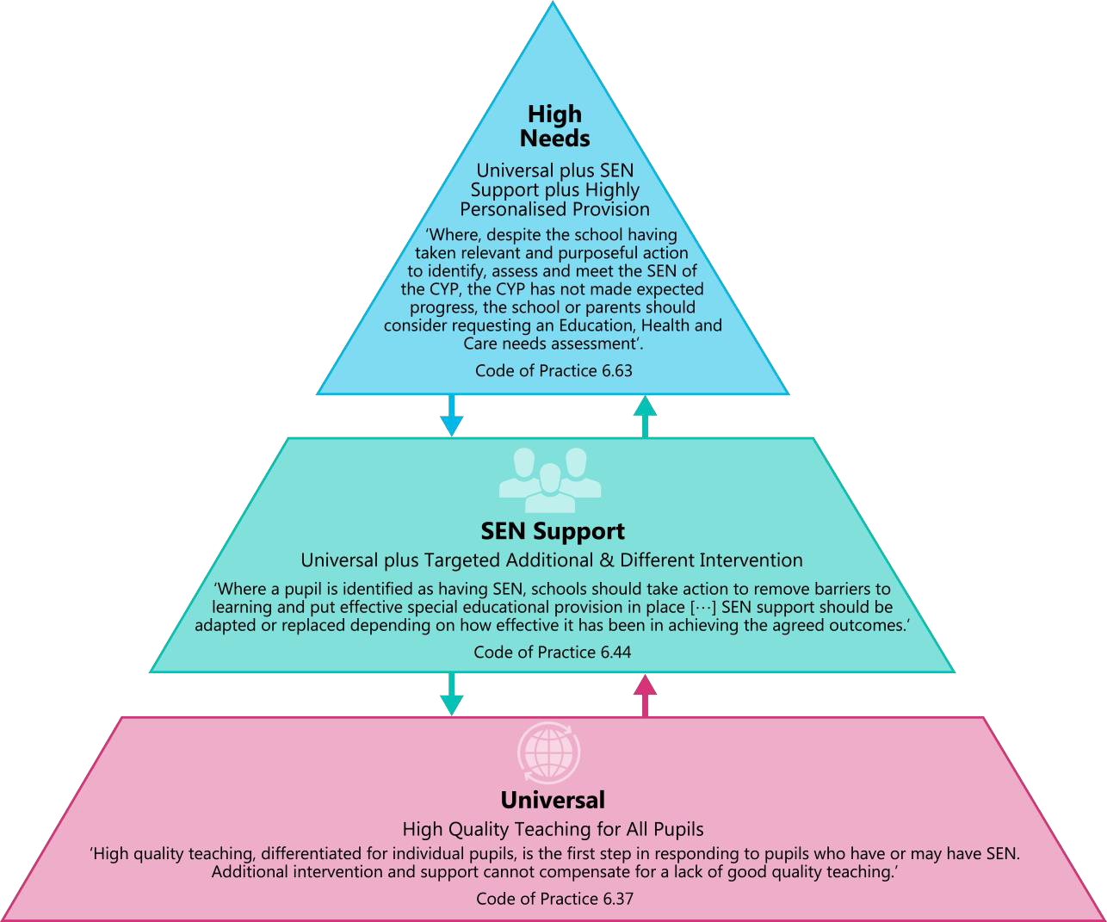
For most children or young people where there is a concern, the school should work through a graduated response ‘to ensure the relevant and purposeful action to identify, assess and meet the special educational needs of the child or young person has been taken.’ (CoP 9.14) and as per the Code of Practice 6.44. ‘In a very small minority of cases of children or young people may demonstrate such significant difficulties that a school or other provider may consider it impossible or inappropriate to carry out its full chosen assessment procedure.’(CoP 9.3)

Supporting students moving between phases and preparing for adulthood
We work with students, parents and carers, feeder schools and other professionals to understand a student’s needs before they join Frome College. Where needed, we arrange additional transition support, such as visits, meetings or sharing information with key staff.
When students move between year groups or experience a significant change to their timetable or support, we review their needs and share relevant information with the staff working with them. Students and their families are involved in planning support for these changes.
As students prepare for their next steps, we support them to explore post-16 education, training and other opportunities. For students with an Education, Health and Care Plan (EHCP), preparation for adulthood and future choices are discussed as part of the annual review. With the student’s and family’s involvement, we share relevant information with their next setting to support a smooth transition.

Our approach to teaching students with SEND
At Frome College we aim to give all students, including those with SEND, access to a broad and balanced curriculum. Teachers are responsible and accountable for the progress and development of all the students in their class.
High-quality teaching is our first step in responding to students who have SEND. This will be differentiated for individual students.
To help every student fulfil their potential we value a wide range of approaches to support students’ learning.

Adaptations to the curriculum and learning environment
At Frome College we provide a broad and balanced curriculum for all students. We have an inclusive approach to provision which means that the majority of students have their needs met within the classroom through appropriately adapted lessons. Where appropriate some personalised learning opportunities may occur and we make the following adaptations to ensure all students’ needs are met:
    - Adapting our curriculum to ensure all students are able to access it, for example, by grouping, 1:1 work, teaching style, content of the lesson, etc.
    - Adapting our resources and staffing
    - Using recommended aids, such as laptops, coloured overlays, visual timetables, larger fonts, etc.
    - Adapting our teaching, for example, giving longer processing times, pre-teaching of key vocabulary, reading instructions aloud, etc.

Additional support for learning
We have a growing team of teaching assistants who are trained to deliver interventions such as:
    - Maths Interventions to enhance number skills
    - English interventions, focusing on literacy skills
    - Handwriting and touch typing skills
    - Learning support mentors to provide pastoral and emotional support
    - 1:1 and small group interventions focusing on specific subjects, depending on individual need.
    - Understanding Autism
    - Executive Functioning Skills.

We work with the following to provide support for students with SEND:
    - Visual Impairment Support Team
    - Hearing Impairment Support Team
    - PIMS Team (Physical Impairment and Medical Support Team)
    - Speech and Language Team
    - Access to Inclusion
    - Educational Psychologist
    - Parent Family Support Advisors
    - Family Intervention Workers
    - Somerset SEND team.

In May 2025 the British Dyslexia Association awarded Frome College with the ‘Dyslexia Friendly Quality Mark’ in recognition of the practices and support provided for our dyslexic students.

ELP – Enhanced Learning Provision
The ELP provides a bespoke course of study for students who would otherwise find it difficult to be successful in other settings. It supports students who benefit from developing both social confidence strategies and their study skills. The ELP provides a reduced-sensory environment in which we build positive relationships and equip our students with essential life skills. Students are supported and encouraged in their personal and academic development.
ELP students would normally struggle to access full or partial mainstream education generally due to literacy/ numeracy levels; their SEND need and/or their ability to cope with a mainstream environment including moving around the school site. ELP students are encouraged to access mainstream lessons where possible. Most ELP students have or will have an EHCP.

ASPIRE
The Aspire Unit is a dedicated Social, Emotional, and Mental Health (SEMH) provision designed to support vulnerable students successfully re-engage with education.
It provides a safe and nurturing environment where students feel secure enough to learn and grow. The heart of the provision is the focus on relationship-led and trauma-informed practice, allowing students to build deep trust with emotionally available key staff. This supportive environment allows students to explore their own barriers to learning and encourages them to aspire to success.
Academically, the unit follows the GCSE curriculum for core subjects while offering pathways to additional qualifications, ensuring learners not only experience academic success but also, do not fall behind their mainstream peers. By teaching in small, highly supportive groups, the Aspire Unit balances academic achievement with the development of vital life skills, emotional regulation, and personal resilience.

Expertise and training of staff
Our SENCO team has many years’ experience in leadership, pastoral support and high-quality teaching and support. Mr Owsley holds the NASENCO Award (National Award for Special Educational Needs Coordinator) as well as an MA in Education and an MBA in Senior Leadership. Mrs Blake has an extensive background as a SEND teacher and is a fully qualified TEEP trainer, has specialist training in SCERTS and Makaton and is currently studying for her NPQML.
They are allocated dedicated time each week to manage SEND provision.
We have a team of teaching assistants, including 2 higher level teaching assistants (HLTAs) who are trained to deliver SEND provision.

We use specialist staff for exam access arrangements testing and dyslexia screening. Staff have been trained in:
- Self-Injury Training
- Sensory Processing Training
- Understanding Autism
- Introduction to Adverse Childhood Experiences
- Introduction to Dyslexia and Inclusive Practice
- Developing Pupils Emotional Literacy and Skills
- Visual Awareness Training
- Literacy interventions.

Securing equipment and facilities
We work with the Physical Impairment Medical Support Team (PIMS), Visual Impairment Team and Hearing Impairment Team to ensure specialist equipment is available to SEND students, where required.

Evaluating the effectiveness of SEND provision
At Frome College we have a variety of different approaches to evaluate the impact of provision for our SEND students. We evaluate the effectiveness of provision for students with SEND in the following ways:
    - Reviewing students’ individual progress towards their goals throughout the academic year
    - Reviewing the impact of interventions to ensure the effectiveness of the provision is matched with the students’ needs
    - Using student questionnaires
    - As part of whole college evaluation process
    - Informal discussions via the Hub drop in
    - Monitoring by the SENCO and Deputy SENCO
    - Holding annual reviews for students with EHC plans
    - Receiving staff feedback from briefings
    - Parents’ Evenings.

​Enabling students with SEND to take part in College life

We aim to make extracurricular activities, clubs, college visits and residential trips accessible to students with SEND. Students are encouraged to take part in sports day, performances and special workshops. We consider the support or reasonable adjustments each student may need to participate.
Disabled students are admitted in accordance with the college’s published admissions arrangements. We work with students, families, previous settings and relevant professionals to identify any support or reasonable adjustments needed when a student joins the college. We also make reasonable adjustments to teaching, resources and the college environment to prevent disabled students being placed at a substantial disadvantage.
Frome College is a large site with classrooms on the ground and first floors. Two buildings have lifts. Where a student needs a ground-floor classroom in another building, we arrange this where possible. Ramps are available where required. The college also has an accessible toilet, changing area and hoist.
Our [Accessibility Plan] explains how we plan to improve disabled students’ access to the curriculum, the physical environment and information. [Add link to Accessibility Plan]

Support for improving emotional and social development
We provide support for students to improve their emotional and social development in the following ways:
    - Students with SEND are encouraged to be part of the college council
    - Students with SEND are also encouraged to be part of extra-curricular clubs to promote teamwork/building friendships.
    - We have a number of intervention programs to support students with mental health needs.
    - Students can be referred to ELSA and external counsellors
    - We work closely with the British Dyslexia Association
    - We have a zero-tolerance approach to bullying and we are part of the Anti-Bullying National Alliance.

Working with other agencies
In some cases, the complexity of needs or lack of clarity around the needs of a student, means the college may want to access some external agencies which provide advice or support to the student and college. An EHA (Early Help Assessment) form is completed in discussion with parents/carers. Specific agencies are then named on the EHA for the parents/carers to approve and sign. Some of the agencies include:
    - CAMHS
    - Speech and Language Team
    - PIMS Team
    - Family Intervention Service
    - Educational Psychology Service
    - Parent Family Support Worker
    - Education Safeguarding Service
    - Young Carers
    - Vision Support Team
    - Social Services
    - Access to Inclusion

Complaints about SEND provision
If you have a concern about our SEND provision, please contact the SEND team in the first instance.
Further information can be found in our complaints procedure.
Link to procedure

The local authority local offer

Our local authority’s local offer is published here: https://www.somerset.gov.uk/children-families-and-education/the-local-offer

Introduction

Somerset’s SEND Local Offer is our hub of information, advice and guidance about the support and services available locally to children and young people aged 0-25 years with special educational needs and/or disabilities (SEND) and their families.

The information and services on this website are for all children and young people with SEND that the local authority is responsible for, whether or not they have an Education, Health and Care Plan (EHCP), to help families to make the best decisions.
Somerset’s SEND Local Offer is also an important resource for professionals to support understanding of the range of services and provisions for children and young people with SEND across the county.

You can read more about what we aim to do, how we will get there in the SEND Strategy and our plans. And you can read more about our plan for improving services for children and young people with SEND in Somerset.

There is also a collection of videos on YouTube that further explain our offer.

How is the Local Offer produced?
Somerset’s Local Offer was first published 1 September 2014. It has been co-produced between Somerset Council, NHS Somerset, Somerset Parent Carer Forum (SPCF) and young people’s groups in schools and colleges. It was also initially developed through commissioned activity with Compass Disability.
Some of the principles we work towards are described in Somerset’s SEND Local Offer Accessibility Strategy. We now keep it up to date and make sure it reflects and embeds the needs of service users through a process co-produced with the SPCF and Somerset Council’s SEND Participation and Engagement Team.

Working with parents and young people

“All aspects of services in Somerset’s Local Offer are developed in partnership with parent carers, young people and practitioners in agencies and the voluntary sector. Somerset’s Local Offer empowers parents, carers, young people and practitioners by setting out clearly what can be expected locally, how to access services and where to find more information. We are working more closely with children and young people with SEND and their families to understand and learn from their experiences when formulating strategies to improve the area.

We work directly with parents and carers through:

- the Somerset Parent Carer Forum, and
- Somerset Special Educational Needs and Disability Information Advice and Support Service (SENDIAS)
We work directly with young people through:

- Somerset Council’s SEND Participation Team.
- Somerset Council’s Young Person’s Champion.

Get in touch

Somerset’s Local Offer is reviewed regularly. We encourage all forms of feedback – positive and negative – so that we can continue to develop and improve the website and our offer of services to make sure it remains useful.

You can find out how to give feedback in the ‘How can I include my feedback’ section of our Keeping the Local Offer up to date page”

Education, Health and Care Plan
^{Master of Arts}
Master of Business Administration
Teacher Effectiveness Enhancement Programme
Social Communication, Emotional Regulation and Transactional Supports
National Professional Qualification for Middle Leadership

